Assignment 4

wokwi for the ultrasonic sensor.

|  |  |
| --- | --- |
| Assignment Date | 29 OCT 2022 |
| Student Name | P .suriya |
| Student Roll Num | 9106191040891 |
| Maximum Marks | 2 Marks |

# QUESTION 1

**Write code and connections in wokwi for ultrasonic sensor.Whenever distance is less than 100 cms send "alert " to ibm cloud and display in device recent events. Upload document with wokwi share link and image of ibm cloud**

# Code:

#include"WiFi.h" #include"WiFiclient.h"

#define DEVICE_TYPE"ESP32_controller" #define DEVICE_ID"Assignment_4" #define TOKEN"&S?LQdLRzh3n2gkyDt"

char server[]=ORG".meassaging.internertofthings.ibmcloud.com"; char pubTopic1[]="iot-2/evt/status1/fmt/json";

char authMethod[]="use-token-auth"; char token[]=TOKEN;

char clientId[]="d:" ORG ":" DEVICE_TYPE ":" DEVICE_ID;

long now;

wificlient wificlient;

pubsubclient client(server, 1883, NULL, wificlient);

#define echoPin 2 // attach pin D2 Arduino to pin Echo of HC-SR04 #define trigPin 3 //attach pin D3 Arduino to pin Trig of HC-SR04

// defines variables

long duration; // variable for the duration of sound wave travel int distance; // variable for the distance measurement

void setup() {

pinMode(trigPin, OUTPUT); // Sets the trigPin as an OUTPUT pinMode(echoPin, INPUT); // Sets the echoPin as an INPUT

Serial.begin(9600); // // Serial Communication is starting with 9600 of baudrate speed Serial.println("Ultrasonic Sensor HC-SR04 Test"); // print some text in Serial Monitor Serial.println("with Arduino UNO R3");

}

void loop() {

// Clears the trigPin condition digitalWrite(trigPin, LOW); delayMicroseconds(2);

// Sets the trigPin HIGH (ACTIVE) for 10 microseconds digitalWrite(trigPin, HIGH);

delayMicroseconds(10); digitalWrite(trigPin, LOW);

// Reads the echoPin, returns the sound wave travel time in microseconds duration = pulseIn(echoPin, HIGH);

// Calculating the distance

distance = duration * 0.034 / 2; // Speed of sound wave divided by 2 (go and back)

// Displays the distance on the Serial Monitor Serial.print("Distance: ");

Serial.print(distance); Serial.println(" cm"); delay(500); if(distance<=100)

{

string payload ="{\"d\":{\"Name\":\"" DEVICE_ID"\""; payload += ",\"Distance\":";

payload += distance; payload += "}}";

Serial.print("sending payload: ") Seerial.println(payload);

if (client.publish(pubTopic1, (char*) payload.c_str()))

{

Serial.print("***ALERT***");

}

}

}

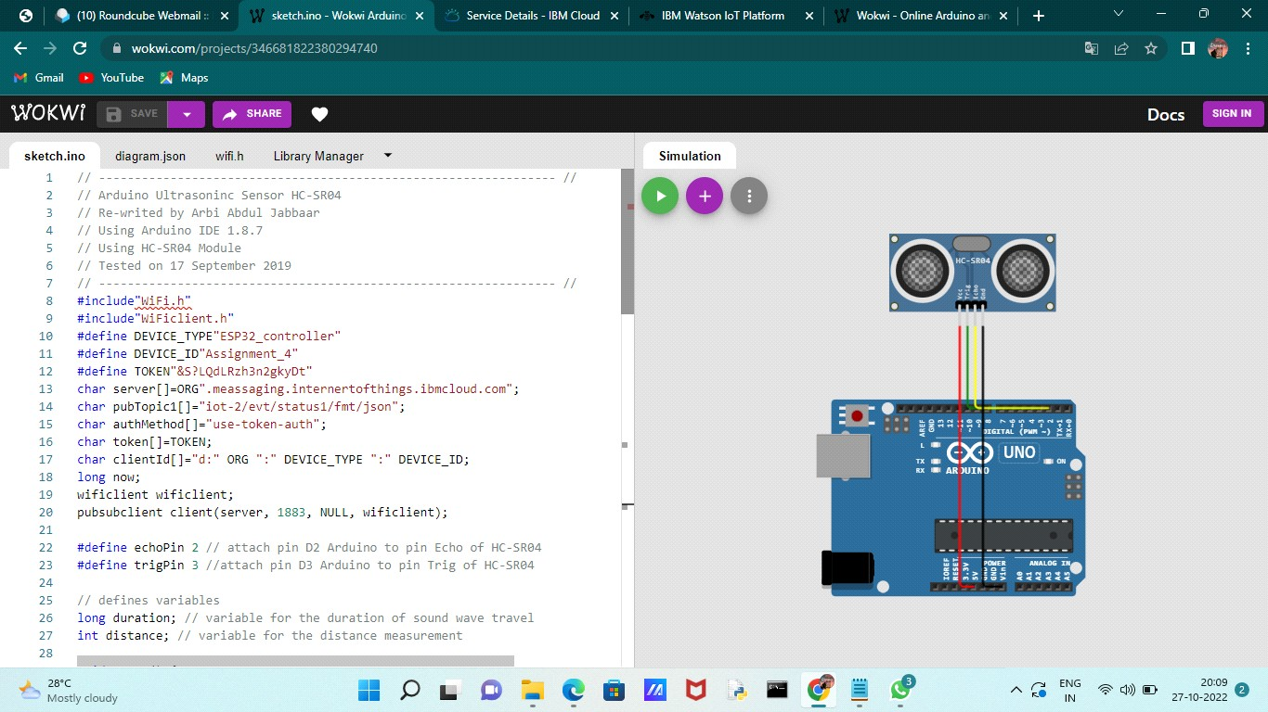

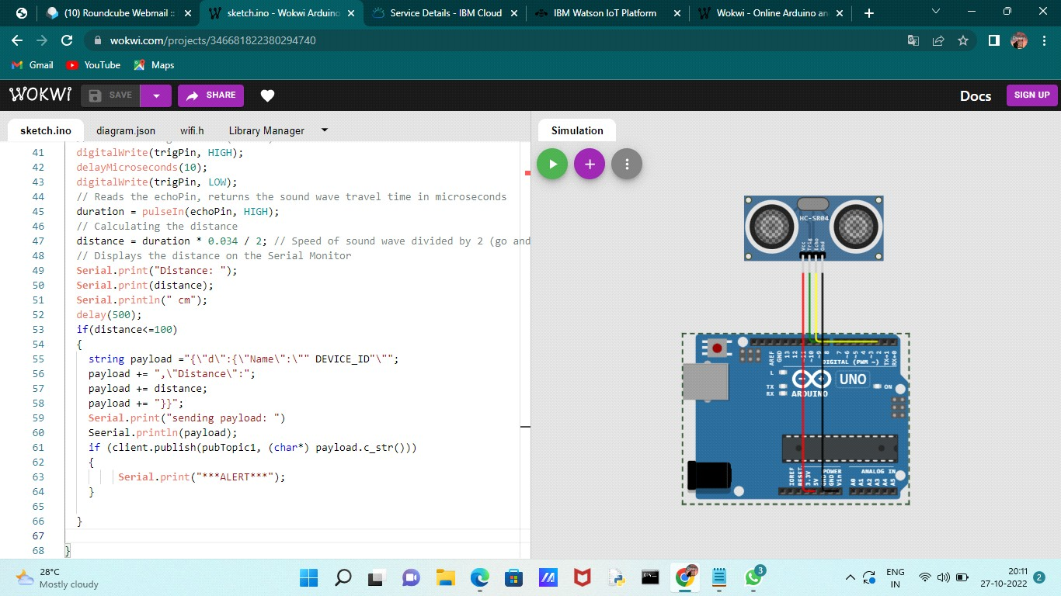

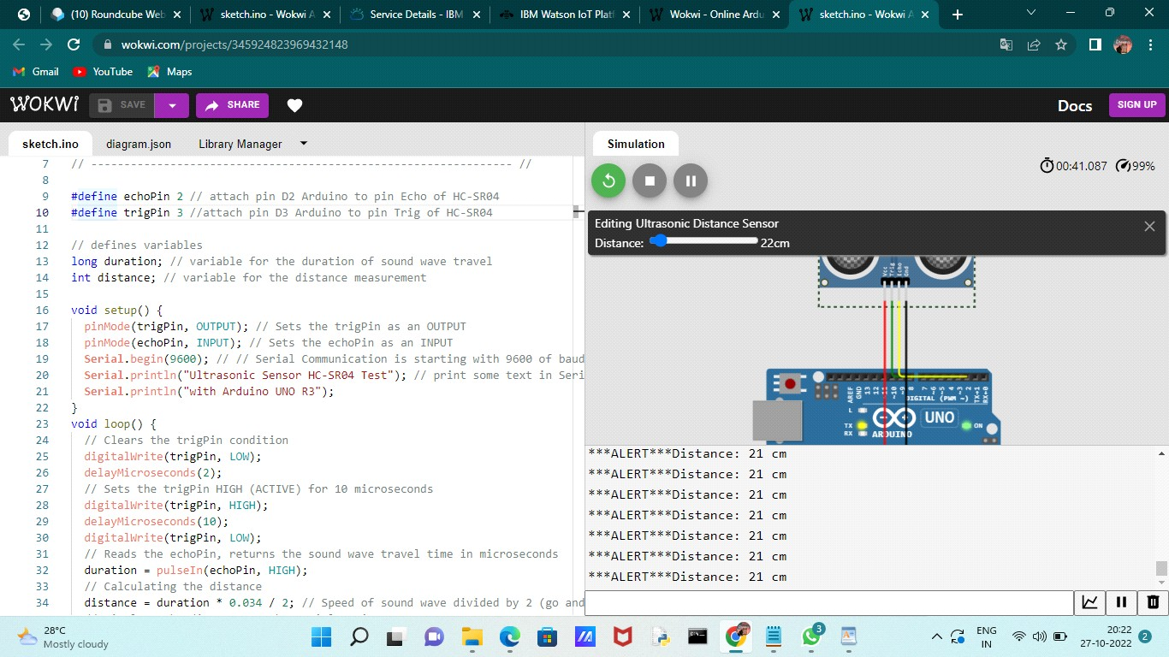

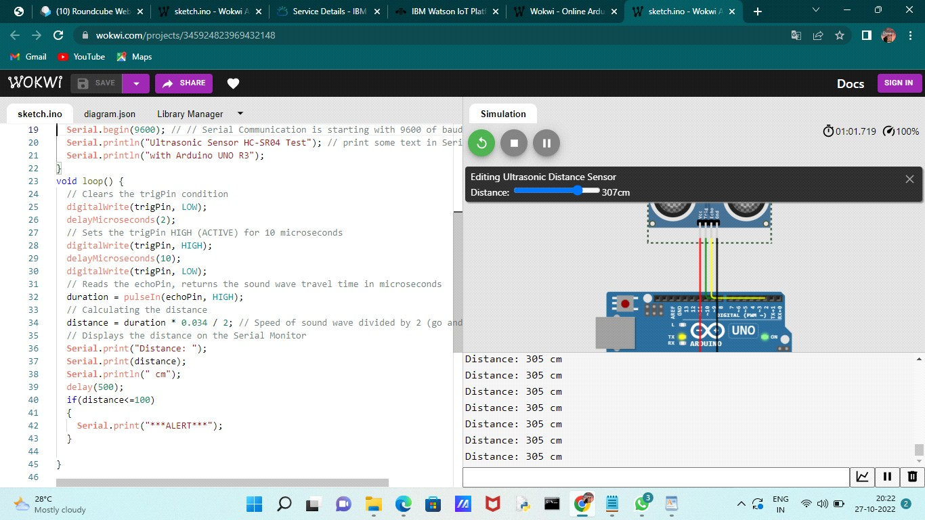

# OUTPUT:

Distance: 305 cm

Distance: 40 cm

***ALERT***Distance: 40 cm